INGLES BASICO Y TECNICO

PAST SIMPLE IRREGULAR VERBS WORKSHEET

Presentado por:

**SANTIAGO CHAPARRO RIAÑO**

Dirigido a:

**ANLLY CAROLINA CORTES CORREA**

CENTRO DE LA INDUSTRIA LAS EMPRESA Y LOS SERVISIOS

NEIVA-HUILA

2024

COMPETENCIA: INGLES

FICHA: 2900177

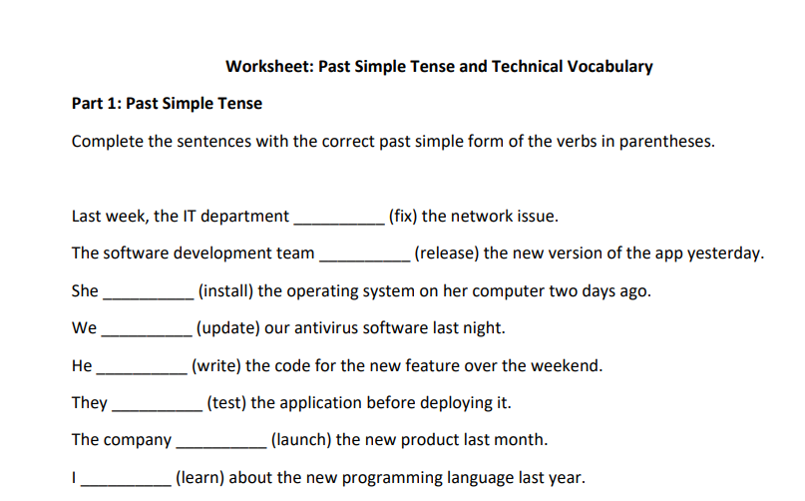

-Last week, the IT department fixed the network issue.

-The software development team released the new version of the app yesterday.

-She installed the operating system on her computer two days ago.

-We updated our antivirus software last night.

-He wrote the code for the new feature over the weekend.

-They tested the application before deploying it.

-The company launched the new product last month.

-I learned about the new programming language last year.

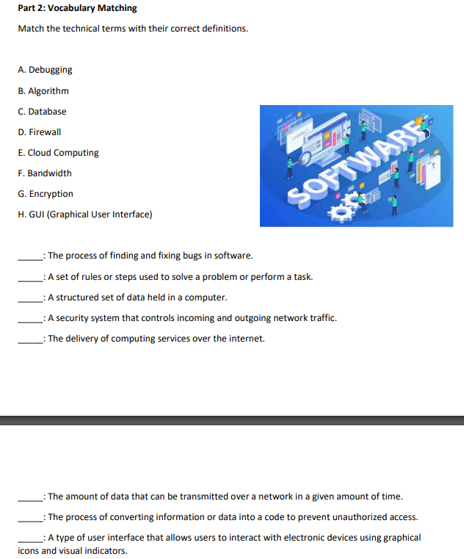

A. Debugging: The process of finding and fixing bugs in software.

B. Algorithm: A set of rules or steps used to solve a problem or perform a task.

C. Database: A structured set of data held in a computer.

D. Firewall: A security system that controls incoming and outgoing network traffic.

E. Cloud Computing: The delivery of computing services over the internet.

F. Bandwidth: The amount of data that can be transmitted over a network in a given amount of time.

G. Encryption: The process of converting information or data into a code to prevent unauthorized access.

H. GUI (Graphical User Interface): A type of user interface that allows users to interact with electronic devices using graphical icons and visual indicators.